**LAPORAN PRAKTIKUM PEMROGAMAN BERBASIS OBJEK**

**PERTEMUAN 9**



Disusun oleh:

Naufal Arya Ramadhan

24060121110042

**LAB C1**

**DEPARTEMEN ILMU KOMPUTER/INFORMATIKA**

**FAKULTAS SAINS DAN MATEMATIKA**

**UNIVERSITAS DIPONEGORO**

**2023**

Source Code

1. PersonDAO.java

|  |
| --- |
| public interface PersonDAO{  public void savePerson(Person p) throws Exception;  } |

1. Person.java

|  |
| --- |
| public class Person{  private int id;  private String name;  public Person(String n) {  name = n;  }    public Person(int i,String n) {  id = i;  name = n;  }    public int getId() {  return id;  }    public String getName() { return name;  }  } |

1. MySQLPersonDAO.java

|  |
| --- |
| import java.sql.*;  public class MySQLPersonDAO implements PersonDAO {  public void savePerson(Person person) throws Exception {  String name = person.getName();    // Creating a connection, adjust the database name, user, and password accordingly  Class.forName("com.mysql.jdbc.Driver");  Connection con = DriverManager.getConnection(  "jdbc:mysql://localhost/pbo", "root", "magefire123");    // Execute the MySQL query  String query = "INSERT INTO person(name) VALUES('" + name + "')";  System.out.println(query);  Statement s = con.createStatement();  s.executeUpdate(query);    // Close the database connection  con.close();  }  } |

1. DAOManager.java

|  |
| --- |
| public class DAOManager{  private PersonDAO personDAO;    public void setPersonDAO(PersonDAO person){  personDAO = person;  }  public PersonDAO getPersonDAO(){  return personDAO;  }  } |

1. MainDAO.java

|  |
| --- |
| public class MainDAO {  public static void main(String[] args) {  Person person = new Person("Indra");  DAOManager daoManager = new DAOManager();  daoManager.setPersonDAO(new MySQLPersonDAO());    try {  daoManager.getPersonDAO().savePerson(person);  } catch (Exception e) {  e.printStackTrace();  }  }  } |

Hasil Run

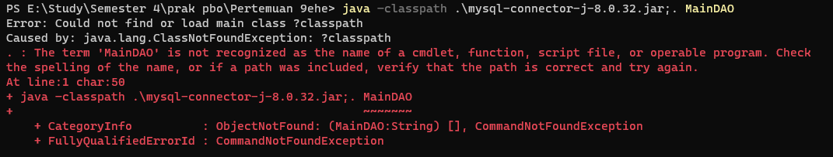

Program error